**EXPERIMENT NO. 05**

|  |
| --- |
| NAME: Ayush Vinod Upadhyay  ROLL NO: I025  SAP ID: 60003220131  BRANCH: Information Technology  BATCH: 1 |

FIRST FIT

#include <stdio.h>

void firstFit(int blockSize[], int m, int processSize[], int n)

{

    int i, j;

    int allocation[n];

    for (i = 0; i < n; i++)

    {

        allocation[i] = -1;

    }

    for (i = 0; i < n; i++)

    {

        for (j = 0; j < m; j++)

        {

            if (blockSize[j] >= processSize[i])

            {

                allocation[i] = j;

                blockSize[j] -= processSize[i];

                break;

            }

        }

    }

    printf("\nProcess No.\tProcess Size\tBlock no.\n");

    for (int i = 0; i < n; i++)

    {

        printf(" %i\t\t\t", i + 1);

        printf("%i\t\t\t\t", processSize[i]);

        if (allocation[i] != -1)

            printf("%i", allocation[i] + 1);

        else

            printf("Not Allocated");

        printf("\n");

    }

}

int main()

{

    int m;

    int n;

    int blockSize[] = {100, 50, 30, 120, 35};

    int processSize[] = {20, 60, 70, 40};

    m = sizeof(blockSize) / sizeof(blockSize[0]);

    n = sizeof(processSize) / sizeof(processSize[0]);

    firstFit(blockSize, m, processSize, n);

    return 0;

}

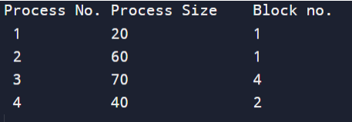

BEST FIT

#include <stdio.h>

void implimentBestFit(int blockSize[], int blocks, int processSize[], int proccesses)

{

    int allocation[proccesses];

    int occupied[blocks];

    for (int i = 0; i < proccesses; i++)

    {

        allocation[i] = -1;

    }

    for (int i = 0; i < blocks; i++)

    {

        occupied[i] = 0;

    }

    for (int i = 0; i < proccesses; i++)

    {

        int indexPlaced = -1;

        for (int j = 0; j < blocks; j++)

        {

            if (blockSize[j] >= processSize[i] && !occupied[j])

            {

                if (indexPlaced == -1)

                    indexPlaced = j;

                else if (blockSize[j] < blockSize[indexPlaced])

                    indexPlaced = j;

            }

        }

        if (indexPlaced != -1)

        {

            allocation[i] = indexPlaced;

            occupied[indexPlaced] = 1;

        }

    }

    printf("\nProcess No.\tProcess Size\tBlock no.\n");

    for (int i = 0; i < proccesses; i++)

    {

        printf("%d \t\t\t %d \t\t\t", i + 1, processSize[i]);

        if (allocation[i] != -1)

            printf("%d\n", allocation[i] + 1);

        else

            printf("Not Allocated\n");

    }

}

int main()

{

    int blockSize[] = {100, 50, 30, 120, 35};

    int processSize[] = {40, 10, 30, 60};

    int blocks = sizeof(blockSize) / sizeof(blockSize[0]);

    int proccesses = sizeof(processSize) / sizeof(processSize[0]);

    implimentBestFit(blockSize, blocks, processSize, proccesses);

    return 0;

}

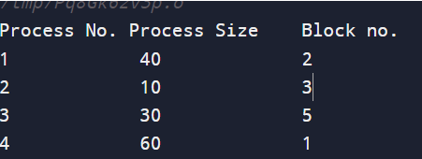

WORST FIT

#include <stdio.h>

void implimentWorstFit(int blockSize[], int blocks, int processSize[], int processes)

{

    int allocation[processes];

    int occupied[blocks];

    for (int i = 0; i < processes; i++)

    {

        allocation[i] = -1;

    }

    for (int i = 0; i < blocks; i++)

    {

        occupied[i] = 0;

    }

    for (int i = 0; i < processes; i++)

    {

        int indexPlaced = -1;

        for (int j = 0; j < blocks; j++)

        {

            if (blockSize[j] >= processSize[i] && !occupied[j])

            {

                if (indexPlaced == -1)

                    indexPlaced = j;

                else if (blockSize[indexPlaced] < blockSize[j])

                    indexPlaced = j;

            }

        }

        if (indexPlaced != -1)

        {

            allocation[i] = indexPlaced;

            occupied[indexPlaced] = 1;

            blockSize[indexPlaced] -= processSize[i];

        }

    }

    printf("\nProcess No.\tProcess Size\tBlock no.\n");

    for (int i = 0; i < processes; i++)

    {

        printf("%d \t\t\t %d \t\t\t", i + 1, processSize[i]);

        if (allocation[i] != -1)

            printf("%d\n", allocation[i] + 1);

        else

            printf("Not Allocated\n");

    }

}

int main()

{

    int blockSize[] = {100, 50, 30, 120, 35};

    int processSize[] = {40, 10, 30, 60};

    int blocks = sizeof(blockSize) / sizeof(blockSize[0]);

    int processes = sizeof(processSize) / sizeof(processSize[0]);

    implimentWorstFit(blockSize, blocks, processSize, processes);

    return 0;

}

